Perpendicular from Center to Chord
# Source: AI Source: Provided by: [Data Path: Persons Table -> ID Column: 1, Name_En Column: Motasem Essam] -> From: [ChatGPT] on [7/25/2026]
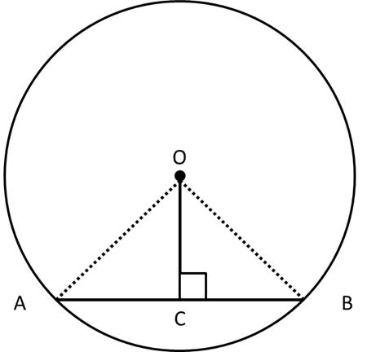
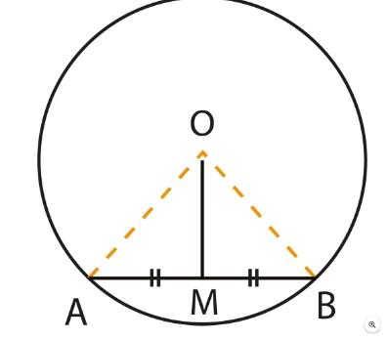
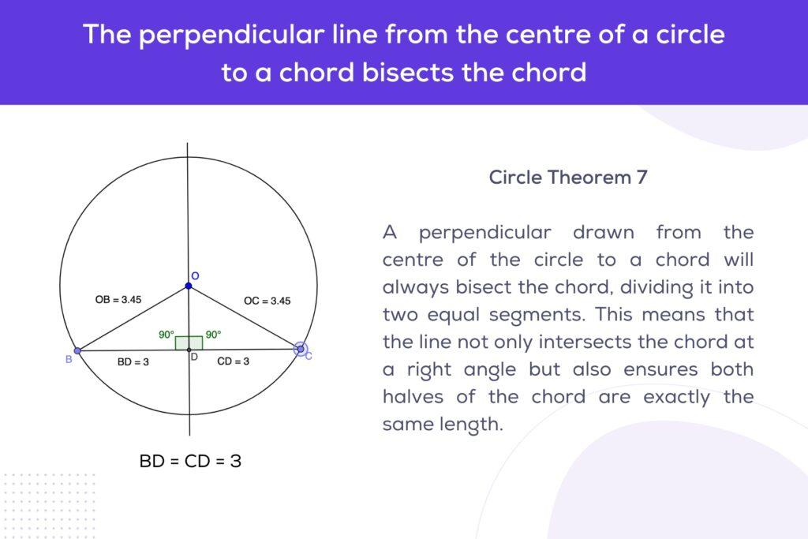
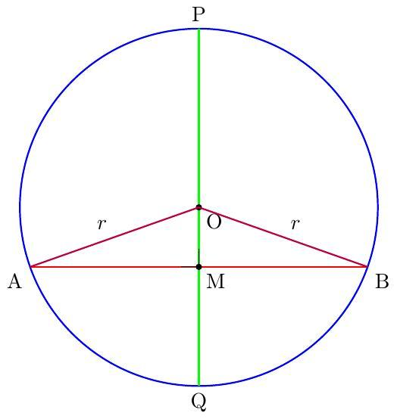

Definition
# Source: AI Source: Provided by: [Data Path: Persons Table -> ID Column: 1, Name_En Column: Motasem Essam] -> From: [ChatGPT] on [7/25/2026]
The Perpendicular from the Center to a Chord is the line segment drawn from the center of a circle perpendicular to a chord.
If $O$is the center of a circle, $AB$is a chord, and $M$is the point where the perpendicular meets the chord, then:
$$\boxed{OM⊥AB}$$
The key theorem is:
$$\boxed{\text{The perpendicular from the center of a circle to a chord bisects the chord.}}$$
Therefore,
$$\boxed{AM=MB}$$

Fundamental Concept
# Source: AI Source: Provided by: [Data Path: Persons Table -> ID Column: 1, Name_En Column: Motasem Essam] -> From: [ChatGPT] on [7/25/2026]
Consider a circle with center $O$and chord $AB$. Draw $OM$perpendicular to $AB$.
genui{"learning_viz":{"type_id":"RIGHT_TRIANGLE"}}
Because $OA$and $OB$are radii:
$$OA=OB$$
And because $OM$is perpendicular to $AB$:
$$∠OMA=∠OMB={90}^{∘}$$
The two right triangles $OMA$and $OMB$are congruent by RHS (Right angle–Hypotenuse–Side) congruence.
Therefore:
$$\boxed{AM=MB}$$
So $M$is the midpoint of chord $AB$.

Main Parts
# Source: AI Source: Provided by: [Data Path: Persons Table -> ID Column: 1, Name_En Column: Motasem Essam] -> From: [ChatGPT] on [7/25/2026]
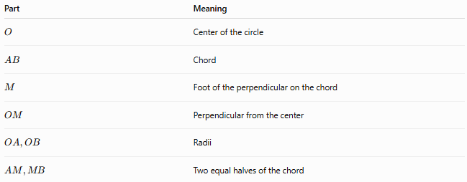
Part | Meaning
$$O$$ | Center of the circle
$$AB$$ | Chord
$$M$$ | Foot of the perpendicular on the chord
$$OM$$ | Perpendicular from the center
$$OA,OB$$ | Radii
$$AM,MB$$ | Two equal halves of the chord
The fundamental relationships are:
$$OM⊥AB \\ OA=OB \\ AM=MB$$

Perpendicular Chord Theorem
# Source: AI Source: Provided by: [Data Path: Persons Table -> ID Column: 1, Name_En Column: Motasem Essam] -> From: [ChatGPT] on [7/25/2026]
Theorem
A perpendicular drawn from the center of a circle to a chord bisects the chord.
If:
$$OM⊥AB$$
then:
$$\boxed{AM=MB}$$
This is one of the fundamental relationships between the center, radius, and chord of a circle.

Converse Theorem
# Source: AI Source: Provided by: [Data Path: Persons Table -> ID Column: 1, Name_En Column: Motasem Essam] -> From: [ChatGPT] on [7/25/2026]
The converse is also important:
The line joining the center of a circle to the midpoint of a chord is perpendicular to the chord.
If:
$$AM=MB$$
then:
$$\boxed{OM⊥AB}$$
Therefore:
$$\boxed{OM⊥AB ⟺ AM=MB}$$
provided $M$lies on chord $AB$.

Mathematical Relationships
# Source: AI Source: Provided by: [Data Path: Persons Table -> ID Column: 1, Name_En Column: Motasem Essam] -> From: [ChatGPT] on [7/25/2026]
Suppose:
- $r$= radius
- $d$= perpendicular distance from the center to the chord
- $c$= chord length
- $M$= midpoint of the chord
Then:
$$OM=d$$
and
$$AM=MB=\frac{c}{2}$$
Since triangle $OMA$is a right triangle:
$$OA^{2}=OM^{2}+AM^{2}$$
Therefore:
$$\boxed{r^{2}=d^{2}+{\left(\frac{c}{2}\right)}^{2}}$$

Chord Length Formula
# Source: AI Source: Provided by: [Data Path: Persons Table -> ID Column: 1, Name_En Column: Motasem Essam] -> From: [ChatGPT] on [7/25/2026]
From the right triangle:
$${\left(\frac{c}{2}\right)}^{2}=r^{2}-d^{2}$$
Therefore:
$$\boxed{c=2\sqrt{r^{2}-d^{2}}}$$
where:
- $c$= chord length
- $r$= circle radius
- $d$= perpendicular distance from center to chord.
Example
A circle has radius $10$cm, and a chord is $6$cm from the center.
$$c=2\sqrt{{10}^{2}-6^{2}} \\ c=2\sqrt{100-36} \\ c=2\sqrt{64} \\ \boxed{c=16\text{ cm}}$$

Finding the Distance from the Center
# Source: AI Source: Provided by: [Data Path: Persons Table -> ID Column: 1, Name_En Column: Motasem Essam] -> From: [ChatGPT] on [7/25/2026]
The same relationship can be rearranged:
$$r^{2}=d^{2}+{\left(\frac{c}{2}\right)}^{2}$$
Therefore:
$$\boxed{d=\sqrt{r^{2}-{\left(\frac{c}{2}\right)}^{2}}}$$
Example
A circle has radius $13$cm and chord length $10$cm.
$$d=\sqrt{{13}^{2}-{\left(\frac{10}{2}\right)}^{2}} \\ d=\sqrt{169-25} \\ d=\sqrt{144} \\ \boxed{d=12\text{ cm}}$$

Equal Chords and Distance from the Center
# Source: AI Source: Provided by: [Data Path: Persons Table -> ID Column: 1, Name_En Column: Motasem Essam] -> From: [ChatGPT] on [7/25/2026]
An important related theorem is:
In the same circle, equal chords are equidistant from the center.
If:
$$AB=CD$$
and their perpendicular distances from the center are $OM$and $ON$, then:
$$\boxed{OM=ON}$$
The converse is also true:
$$\boxed{OM=ON⇒AB=CD}$$
So:
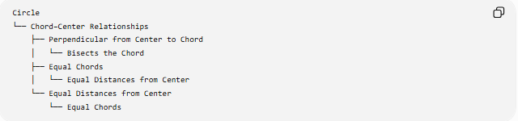
Circle
└── Chord–Center Relationships
├── Perpendicular from Center to Chord
│ └── Bisects the Chord
├── Equal Chords
│ └── Equal Distances from Center
└── Equal Distances from Center
└── Equal Chords

Special Cases

A. Chord Through the Center
# Source: AI Source: Provided by: [Data Path: Persons Table -> ID Column: 1, Name_En Column: Motasem Essam] -> From: [ChatGPT] on [7/25/2026]
If the chord passes through the center, it is a diameter.
Then:
$$d=0$$
and:
$$c=2\sqrt{r^{2}}=2r$$
Therefore:
$$\boxed{c=2r}$$
The perpendicular from the center to the diameter meets it at its midpoint.

B. Chord Very Close to the Circumference
# Source: AI Source: Provided by: [Data Path: Persons Table -> ID Column: 1, Name_En Column: Motasem Essam] -> From: [ChatGPT] on [7/25/2026]
As the chord approaches the circumference:
$$d→r$$
and:
$$c→0$$
Thus, shorter chords are closer to the circumference.

C. Chord Closest to the Center
# Source: AI Source: Provided by: [Data Path: Persons Table -> ID Column: 1, Name_En Column: Motasem Essam] -> From: [ChatGPT] on [7/25/2026]
For a fixed circle, the chord with the smallest distance from the center is the diameter.
The diameter is also the longest chord.
Therefore:
$$\boxed{\text{Closer chord to center}⇒\text{longer chord}}$$
and:
$$\boxed{\text{Farther chord from center}⇒\text{shorter chord}}$$

Proof of the Theorem
# Source: AI Source: Provided by: [Data Path: Persons Table -> ID Column: 1, Name_En Column: Motasem Essam] -> From: [ChatGPT] on [7/25/2026]
Given:
$$OM⊥AB$$
We need to prove:
$$AM=MB$$
Consider triangles:
$$△OMA$$
and
$$△OMB$$
We know:
- $OA=OB$, because they are radii of the same circle.
- $OM=OM$, common side.
- $∠OMA=∠OMB={90}^{∘}$.
Therefore:
$$△OMA≅△OMB$$
by RHS congruence.
Hence corresponding sides are equal:
$$\boxed{AM=MB}$$
Therefore, the perpendicular from the center bisects the chord.

Relationship with the Central Angle
# Source: AI Source: Provided by: [Data Path: Persons Table -> ID Column: 1, Name_En Column: Motasem Essam] -> From: [ChatGPT] on [7/25/2026]
If $OM$is perpendicular to chord $AB$, then $OM$also bisects the central angle subtended by the chord.
Therefore:
$$\boxed{∠AOM=∠MOB}$$
This gives the chain:
$$OM⊥AB \\ ⇓ \\ AM=MB$$
and also:
$$\boxed{∠AOM=∠MOB}$$

Relationship with the Arc
# Source: AI Source: Provided by: [Data Path: Persons Table -> ID Column: 1, Name_En Column: Motasem Essam] -> From: [ChatGPT] on [7/25/2026]
A chord and its perpendicular bisector have corresponding symmetry in the circle.
If $OM⊥AB$and $AM=MB$, then the two arcs cut off by $A$and $B$on either side of the perpendicular are equal.
Thus:
$$\boxed{\hat{ACB}=\hat{ADB}}$$
when the two arcs are the corresponding arcs between $A$and $B$.
More simply:
$$\boxed{\text{Equal chord halves}⇒\text{equal corresponding arcs}}$$

Important Properties
# Source: AI Source: Provided by: [Data Path: Persons Table -> ID Column: 1, Name_En Column: Motasem Essam] -> From: [ChatGPT] on [7/25/2026]
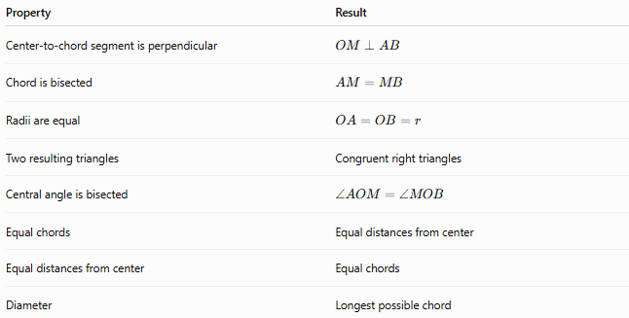
Property | Result
Center-to-chord segment is perpendicular | $$OM⊥AB$$
Chord is bisected | $$AM=MB$$
Radii are equal | $$OA=OB=r$$
Two resulting triangles | Congruent right triangles
Central angle is bisected | $$∠AOM=∠MOB$$
Equal chords | Equal distances from center
Equal distances from center | Equal chords
Diameter | Longest possible chord

Comparison with Related Circle Concepts
# Source: AI Source: Provided by: [Data Path: Persons Table -> ID Column: 1, Name_En Column: Motasem Essam] -> From: [ChatGPT] on [7/25/2026]
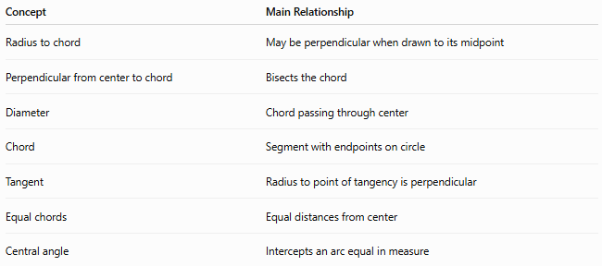
Concept | Main Relationship
Radius to chord | May be perpendicular when drawn to its midpoint
Perpendicular from center to chord | Bisects the chord
Diameter | Chord passing through center
Chord | Segment with endpoints on circle
Tangent | Radius to point of tangency is perpendicular
Equal chords | Equal distances from center
Central angle | Intercepts an arc equal in measure

Key Formulas
# Source: AI Source: Provided by: [Data Path: Persons Table -> ID Column: 1, Name_En Column: Motasem Essam] -> From: [ChatGPT] on [7/25/2026]
Chord–distance relationship
$$\boxed{r^{2}=d^{2}+{\left(\frac{c}{2}\right)}^{2}}$$
Chord length
$$\boxed{c=2\sqrt{r^{2}-d^{2}}}$$
Distance from center to chord
$$\boxed{d=\sqrt{r^{2}-{\left(\frac{c}{2}\right)}^{2}}}$$
Half-chord
$$\boxed{\frac{c}{2}=\sqrt{r^{2}-d^{2}}}$$

Classification
# Source: AI Source: Provided by: [Data Path: Persons Table -> ID Column: 1, Name_En Column: Motasem Essam] -> From: [ChatGPT] on [7/25/2026]
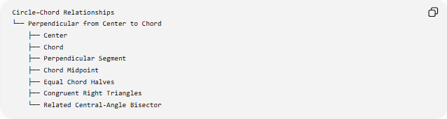
Circle–Chord Relationships
└── Perpendicular from Center to Chord
├── Center
├── Chord
├── Perpendicular Segment
├── Chord Midpoint
├── Equal Chord Halves
├── Congruent Right Triangles
└── Related Central-Angle Bisector

Key Points
# Source: AI Source: Provided by: [Data Path: Persons Table -> ID Column: 1, Name_En Column: Motasem Essam] -> From: [ChatGPT] on [7/25/2026]
- The perpendicular from the center to a chord bisects the chord.
- If $OM⊥AB$, then $AM=MB$.
- The converse is also true: if $M$is the midpoint of $AB$, then $OM⊥AB$.
- Equal chords in the same circle are equidistant from the center.
- Chords closer to the center are longer.
- The diameter is the longest chord because its distance from the center is $0$.
- The chord-distance formula is:
$$\boxed{c=2\sqrt{r^{2}-d^{2}}}$$

Conclusion
# Source: AI Source: Provided by: [Data Path: Persons Table -> ID Column: 1, Name_En Column: Motasem Essam] -> From: [ChatGPT] on [7/25/2026]
The Perpendicular from Center to Chord Theorem establishes a fundamental connection between the center of a circle and its chords:
$$\boxed{OM⊥AB⇒AM=MB}$$
It is useful for proving chord relationships, finding chord lengths, determining distances from the center, and solving many circle-geometry problems.

